1.
On your Windows laptop or PC, open 'System Information' and take a screenshot showing your OS version, processor, and RAM details.
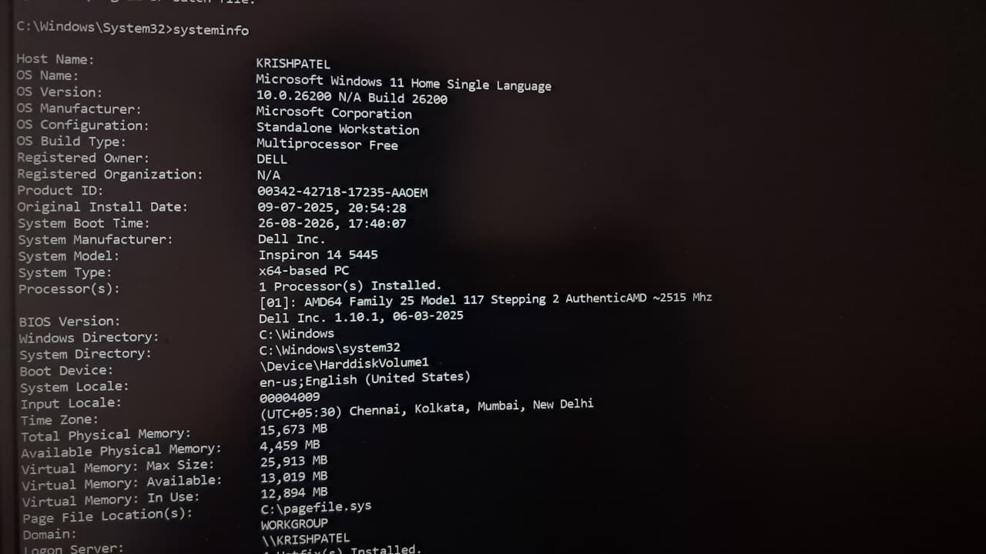

2.
Download any official Linux distribution ISO (like Ubuntu or Fedora), and use Rufus or BalenaEtcher to create a bootable USB drive for installation.<br><br><em><strong>Hint:</strong> If you don't have a spare USB, use a virtual machine tool like VirtualBox to mount the ISO and start the installation process virtually.</em>
- Install VirtualBox (or VMware Workstation Player).
- Create New VM
  - OS type: Linux → Ubuntu/Fedora.
  - Allocate RAM (≥2 GB, ideally 4 GB+).
  - Create virtual hard disk (20 GB+).
- Mount ISO
  - In VM settings → Storage → attach ISO
- Start VM
  - It boots directly from ISO.
  - Proceed with installation inside the virtual environment.

3.
On a macOS device (or using a macOS virtual machine), open 'System Preferences' and change the desktop wallpaper, then adjust the system language to Hindi or Gujarati.<br><br><em><strong>Hint:</strong> Find 'Language & Region' in System Preferences to add or change languages.</em>
- Open System Preferences (click the Apple menu → System Preferences).
- Select Desktop & Screen Saver.
- Choose a new wallpaper from the default options or click + to add your own image.
To Adjust Language:
In System Preferences, open Language & Region.
Click the + button under Preferred languages.
Select Hindi or Gujarati from the list.
Click Add, then confirm when asked to use the new language as the primary system language.
Restart or log out → macOS will now display menus and system text in your chosen language.

4.
Install a fresh copy of Ubuntu Linux (real or virtual machine) and create a new user account named 'gamer'. After installation, enable automatic login for this user and take a screenshot of the login screen showing the username.
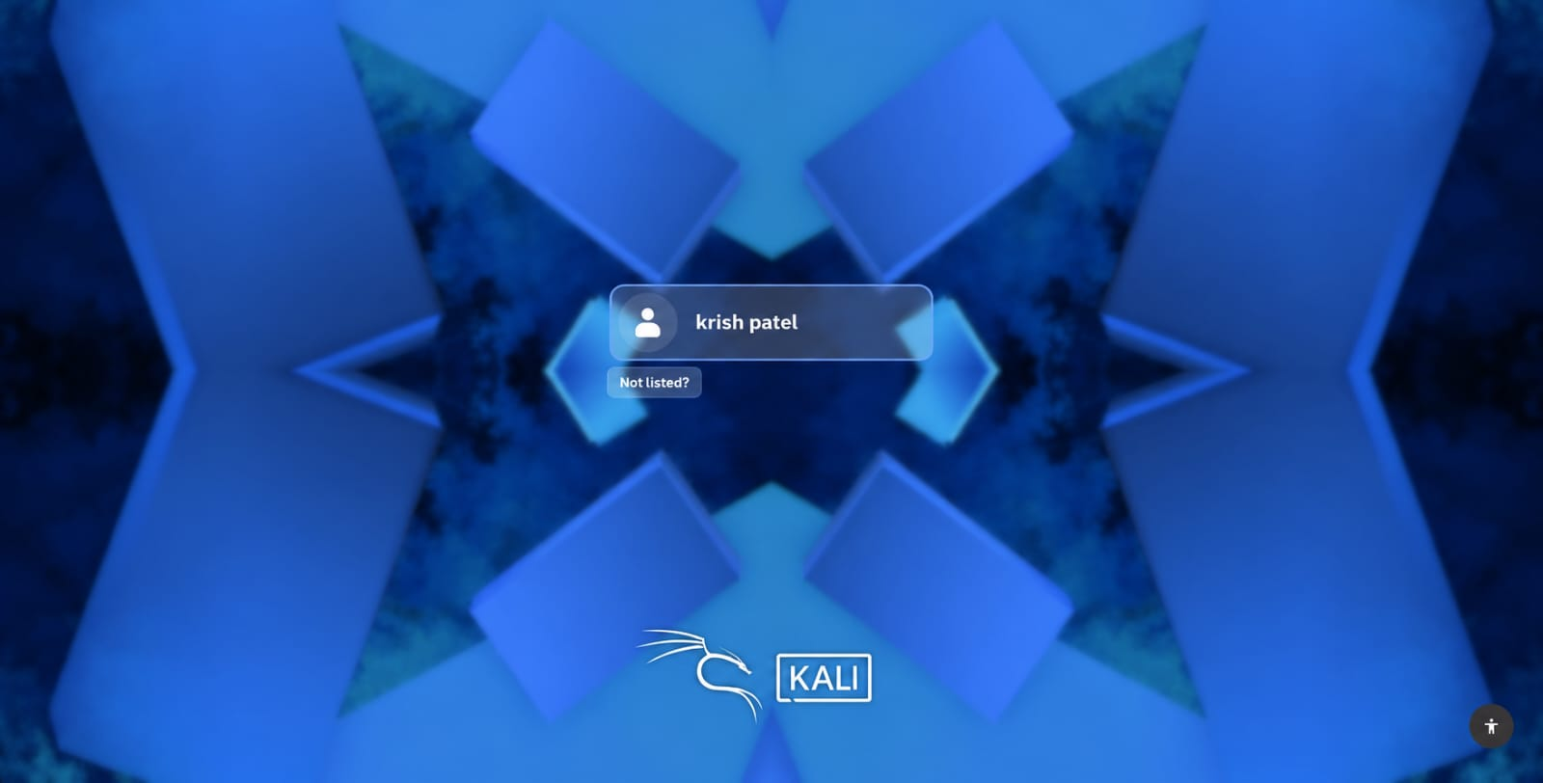
5.
Use ChatGPT to generate a step-by-step guide for installing Windows 10 on a laptop, including partitioning tips and post-installation settings for privacy and updates. Follow the guide and note any steps that were unclear or missing.
Download the official Windows 10 ISO from Microsoft’s website.
Use ventoy to create a bootable USB drive with the ISO.
Insert the USB into your laptop and restart
Enter BIOS/UEFI and set USB as the first boot device.
Save changes and boot from the USB.
Select language, time, and keyboard settings, then click Install Now.
Enter product key or skip if you’ll activate later.
Choose Custom: Install Windows only
Select the drive for installation.
Create partitions:
- 50–100 GB for C: (System).
- Remaining space for D: (Data).
Format partitions and select the system partition for installation.
Windows copies files and restarts automatically.
Create a user account and password.
Open Settings → Update & Security → Windows Update.
Install all pending updates.
Your Windows 10 setup is complete.

